System Architecture for Modern ETL Pipeline with dbt, Snowflake & Web Deployment

System Architecture Document
1. Objective and Purpose of the System
In today’s data-driven environment, organizations collect huge amounts of raw data, but this data is often messy and not ready for direct use. The main objective of this project is to build a modern ETL (Extract, Transform, Load) pipeline that can efficiently process, clean, and organize data using dbt and Snowflake, and make it ready for analysis and web-based applications.
The purpose of this system is:
- To automate data processing
- To ensure high-quality and reliable data
- To provide structured datasets for analytics and dashboards
- To support deployment in real-world web applications
This system bridges the gap between raw data and meaningful insights.

2. Tools, Technologies, and Platforms Used
The project uses modern data engineering tools:
- Snowflake – Cloud data warehouse for storing and processing data
- dbt (Data Build Tool) – Used for transforming data using SQL models
- SQL – Core language for querying and transformation
- Python – For automation and API integration
- Flask / Streamlit – For deploying a simple web application
- Git & GitHub – Version control and collaboration
- REST APIs – For integrating external services (like AI insights)

3. System Setup and Components
The system is divided into multiple layers:
Components:
- Data Sources – CSV files, APIs, or databases
- Data Warehouse (Snowflake) – Stores raw and processed data
- dbt Layer – Handles transformation logic
- Web Application Layer – Displays results to users
- API Layer – Optional AI/insight generation
Setup:
- Configure Snowflake account and create database/schema
- Connect dbt with Snowflake using profiles.yml
- Create dbt models for transformation
- Build and deploy a web app using Flask/Streamlit
- Connect backend with processed data

4. System Design and Flow
Architecture Diagram
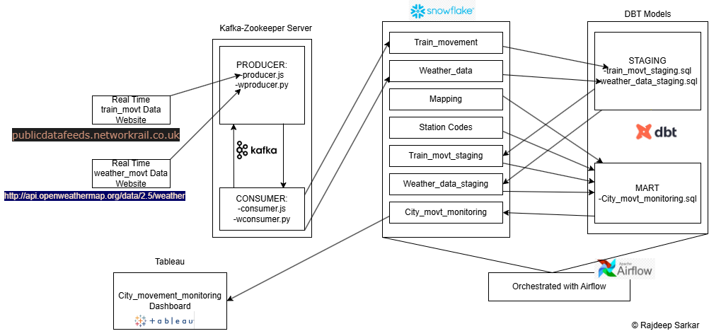
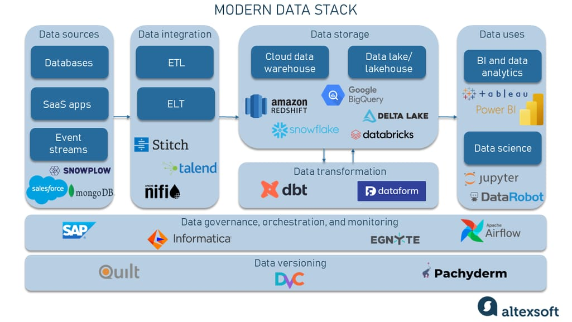
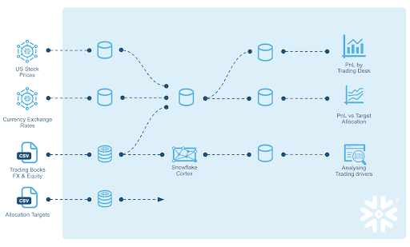
4.Flow Explanation (Step-by-Step)
- Extract
Data is collected from different sources
- Load
Data is stored in Snowflake
- Transform (dbt)
  - Staging: cleaning data
  - Intermediate: joining tables
  - Final: analytics-ready datasets
- Backend Processing
Python fetches processed data
- Web Application
  - Displays data in UI
  - Allows user interaction
- Optional AI Layer
  - Generates insights from processed data

5. Sample Web Application Code (Flask)
from flask import Flask, jsonify
import snowflake.connector
app = Flask(__name__)
# Snowflake connection
conn = snowflake.connector.connect(
user='YOUR_USER',
password='YOUR_PASSWORD',
account='YOUR_ACCOUNT'
)
@app.route('/data')
def get_data():
cursor = conn.cursor()
cursor.execute("SELECT * FROM analytics.sales LIMIT 10")
rows = cursor.fetchall()
return jsonify(rows)
if __name__ == '__main__':
app.run(debug=True)

6. Performance, Scalability, and Reliability
Performance
- Snowflake uses parallel processing for fast queries
- dbt optimizes transformations with incremental models
Scalability
- Easily handles large datasets
- Can scale compute resources automatically
Reliability
- dbt testing ensures data quality
- Version control avoids data loss
- Modular design reduces errors

7. Expected Outcomes
After implementing this system, we achieve:
- Clean and structured data
- Automated ETL pipeline
- Faster data processing
- Interactive web-based data access
- Scalable architecture for future growth

8. Conclusion
This project demonstrates how modern tools like dbt and Snowflake can be combined with web technologies to build a complete data pipeline system. The system is efficient, scalable, and reliable, making it suitable for real-world applications. By integrating data processing with web deployment, users can easily access insights and make better decisions.

